**Project Flow: CardMaster – Intelligent Playing Card Recognition using Transfer Learning**

**Overview:**

CardMaster is a high-accuracy model designed for recognizing playing cards through the application of transfer learning techniques. The system leverages a curated dataset comprising 8,154 cropped images of playing cards, organized into training, validation, and test sets. Each image corresponds to one of 53 unique classes (standard 52 cards plus a joker or a back card, depending on dataset design). By employing pre-trained convolutional neural networks (CNNs), the project utilizes transfer learning to achieve efficient and effective feature extraction. This approach reduces both computational overhead and training duration, while maintaining robust performance in card classification tasks.

**Key Application Scenarios:**

**Scenario 1: Digital Card Games**

In modern digital card games, blending physical gameplay with digital interfaces can significantly enhance user experience. CardMaster enables real-time recognition of physical cards, allowing them to be seamlessly integrated into a digital gaming platform. By capturing live images of the cards in play and identifying them instantly, the system updates the digital interface accordingly. This fosters interactive, hybrid gameplay and ensures accuracy, fairness, and user engagement.

**Scenario 2: Casino Surveillance**

Casinos require stringent measures to maintain fairness and detect fraud. CardMaster can be deployed as part of automated surveillance systems to monitor table games. Cameras capture card images, which are then analyzed in real time to detect and log card activity. The system assists security teams in identifying anomalous patterns, misdeals, or potential cheating, thereby bolstering operational security and ensuring game integrity.

**Scenario 3: Interactive Learning Tools**

Educational platforms focused on teaching card games or strategies can leverage CardMaster for a more immersive and hands-on learning experience. The system can observe learners' physical card movements and provide immediate feedback, rule explanations, or strategic suggestions. This facilitates active learning, allowing users to better understand game mechanics and improve their decision-making skills through real-time practice.

**1. Dataset Collection and Loading**

**Files:**

* Downloadable via Kaggle: [Cards Image Dataset – Classification](https://www.kaggle.com/datasets/gpiosenka/cards-image-datasetclassification)

**Description:**

* t contains **8,154 cropped images** of playing cards, categorized into **53 classes** (e.g., Ace of Spades, Two of Hearts).
* The images are already **split** into:
* Training set: 7,624 images
* Validation set: 265 images
* Test set: 265 images

**Why this is important:**

* Clean and well-structured datasets save preprocessing time.
* Having predefined train/val/test splits supports proper model validation and avoids data leakage

**2. Exploratory Data Analysis (EDA) and Visualization**

**Objective:**

* Visually inspect the dataset using random samples from each class
* Understand image distributions and verify class balance
* Validate dataset structure and quality

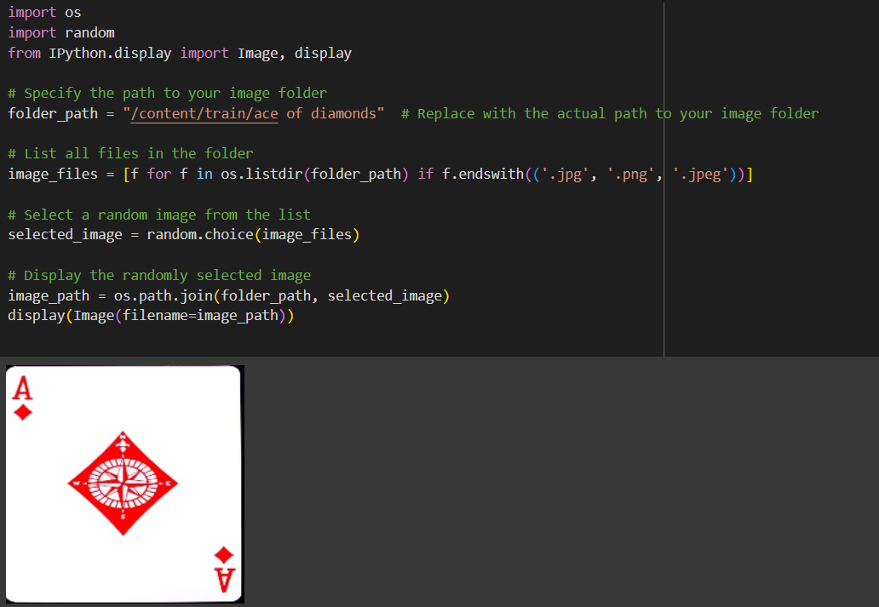

**Outputs:**

* Displayed predictions for random samples (e.g., Ace of Diamonds, Eight of Spades)
* Confirmation that the model correctly identifies cards from visual input

**3. Data Preprocessing and Augmentation**

**Steps:**

**Preprocessing** steps included:

* Resizing images (though already 224x224)
* Normalizing pixel values (typically dividing by 255 to bring into 0-1 range)

**Data augmentation** (e.g., flip, rotate, zoom) was considered but **not applied**:

* The dataset was already cropped and clean.
* Applying augmentation would increase training time without major benefits in this case.

**Outputs:**

* Clean, standardized datasets
* Minimal augmentation applied for efficiency

**4. Model Building and Training**

**Architectures Used:**

* **VGG16**

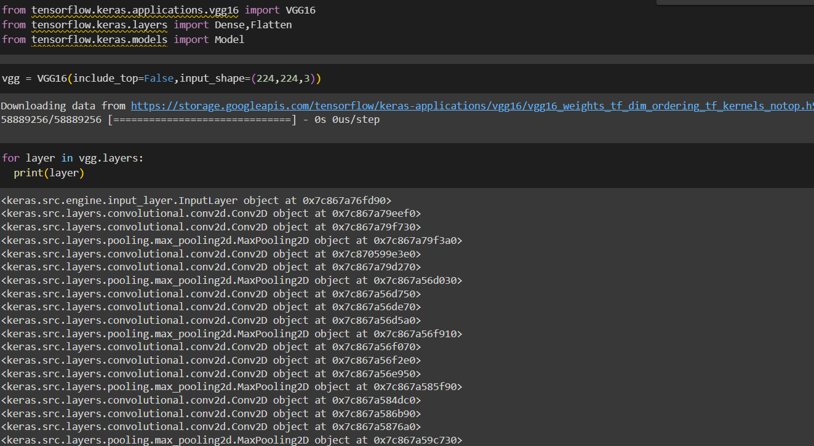

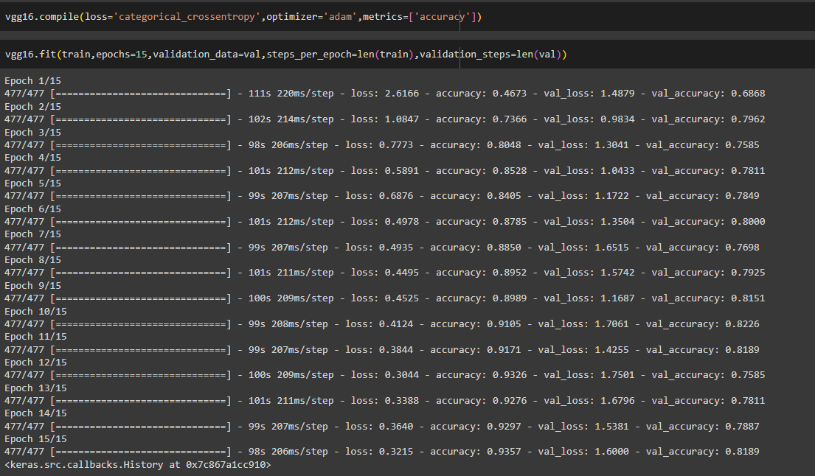

**Overview:**

* VGG16 is a deep CNN architecture developed by the Visual Geometry Group (VGG) at Oxford.
* It has 16 layers: 13 convolutional layers and 3 fully connected layers.
* Known for its simplicity and uniform architecture using only 3x3 convolution filters

**Why VGG16 was used:**

* Excellent feature extractor due to deep architecture.
* Performs well on datasets with clean and well-aligned images like playing cards.
* Easy to integrate using keras.applications.VGG16.
* **InceptionV3**

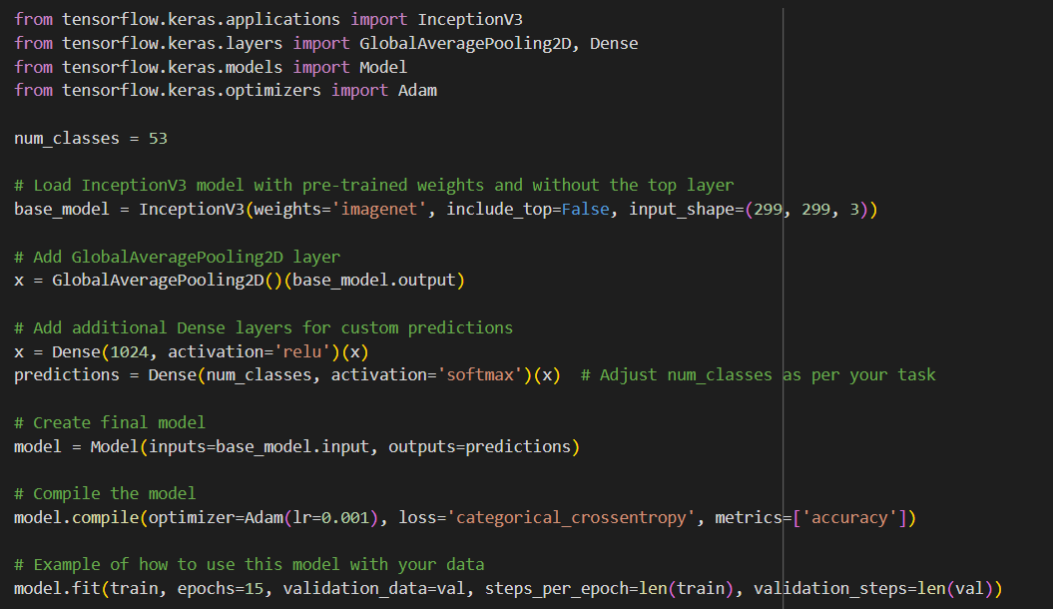

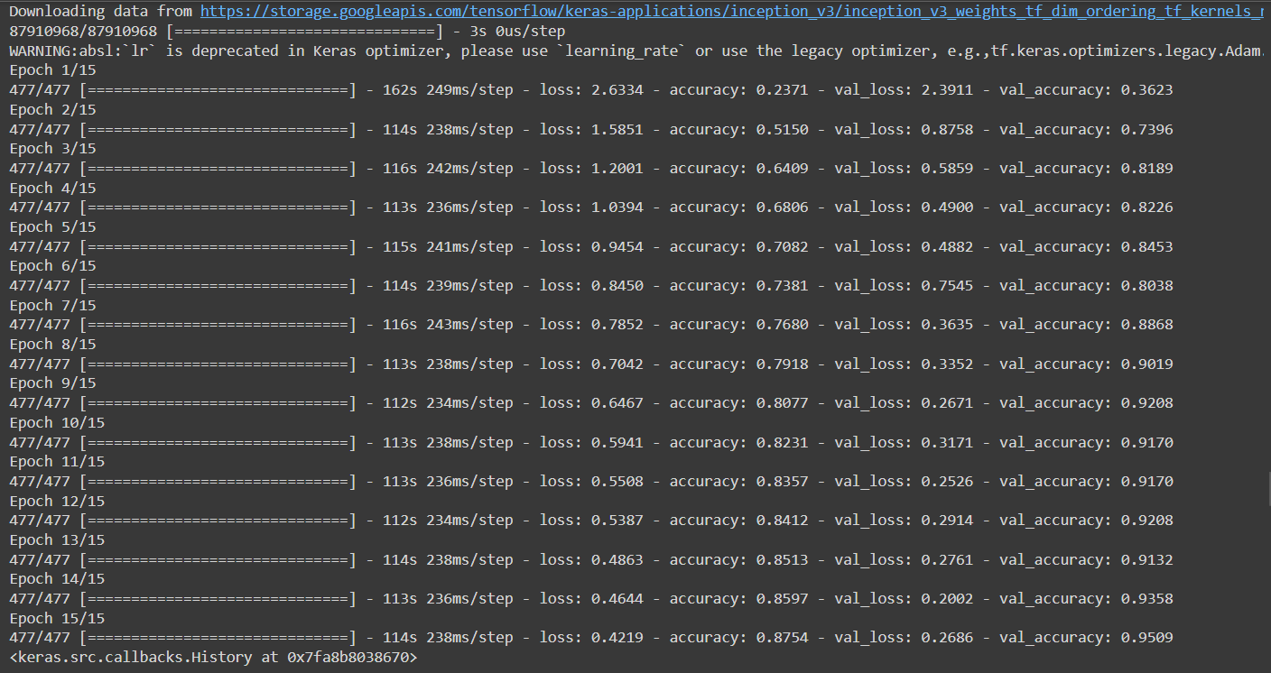

**Overview:**

* InceptionV3 is a deeper and more efficient CNN developed by Google.
* Uses Inception modules, which perform multiple convolutions (1x1, 3x3, 5x5) in parallel and concatenate the results.
* Offers high accuracy with fewer parameters compared to VGG.

**Why InceptionV3 was used:**

* Better generalization on complex data due to its advanced architecture.
* Useful for datasets where different visual scales are important (cards with varied symbols, shapes).
* **Xception**

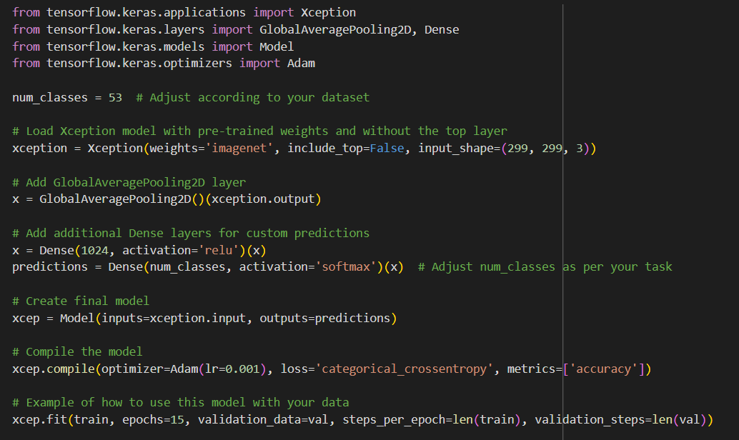

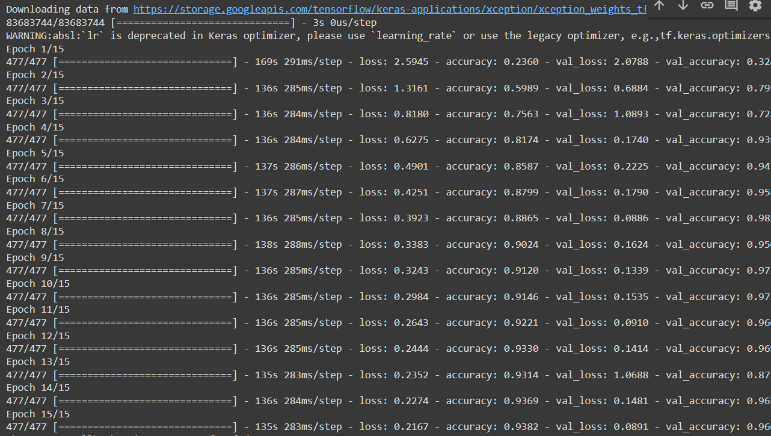

**Overview:**

* Xception (Extreme Inception) is an improvement over Inception.
* Uses depthwise separable convolutions, which drastically reduce computational cost.
* Known for excellent accuracy and efficiency.

**Why Xception was used:**

* Provides faster convergence and often better results than Inception.
* Ideal for high-performance applications with fewer resources.

**Process:**

**1.** Loaded pre-trained models from Keras (include_top=False) to exclude their final layers.

2. **Froze the convolutional layers** to preserve learned features.

3. Added custom dense layers (classifier head) with:

* Dropout (to reduce overfitting)
* Dense + Softmax layer (to classify into 53 categories)

4. Compiled models using:

* **Adam optimizer**
* **sparse_categorical_crossentropy** loss (used when labels are integers)

5. Trained models using:

* **ModelCheckpoint** (to save the best model)
* **EarlyStopping** (to avoid overfitting)

6. The best model (VGG16) was saved as Vgg16_model.h5.

**Outputs:**

* Trained and validated models
* Saved weights for Flask integration

**5. Model Evaluation and Prediction**

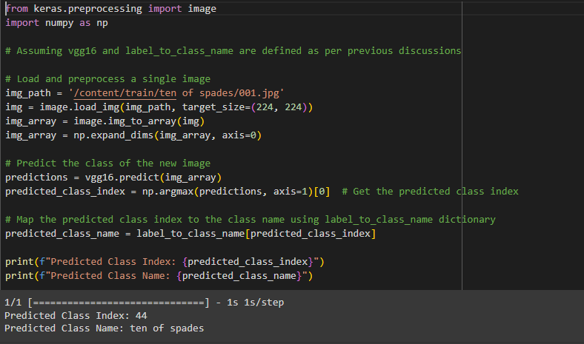

**What was done:**

* The saved VGG16 model was used to predict on the test dataset.
* The model's accuracy was evaluated by predicting real test images such as:
  + Ace of Hearts
  + Ace of Diamonds
  + Ace of Spades
* Model predictions were visualized on the UI and found to be correct.

**Outputs:**

* High prediction accuracy
* Generalizable model performance confirmed on test classes

**6. Web Application Deployment**

**What was done:**

* Built using Flask for backend functionality.
* HTML templates were created (index.html, input.html, output.html) under /templates.
* Static assets (e.g., CSS, images) were stored in /static.

**Flask Routes:**

* /: Load the home page (index.html)
* /predict: Accept image upload and return the predicted class

**How prediction works:**

1. User uploads a card image.
2. Flask reads the image and passes it to the loaded model (Vgg16_model.h5).
3. The model predicts the class, and the result is displayed on output.html.

**Why this is important:**

* Enables real-time predictions via a user-friendly interface.
* Demonstrates full end-to-end deployment of a deep learning model.

**7. Model Serialization and Inference**

**What was done:**

* The final trained model (Vgg16_model.h5) was saved using model.save() (Keras).
* The Flask backend loads this model during startup.

**Purpose:**

* Store model for reuse in prediction pipeline
* Enable Flask app to load the model and generate predictions in real-time

**1. Architecture of the Project**

* **Frontend**: HTML templates with file upload feature
* **Backend**: Flask routes managing image input, prediction, and output rendering
* **Model**: CNN-based transfer learning models (VGG16/Inception/Xception)
* **Inference Pipeline**: Load → Preprocess → Predict → Display

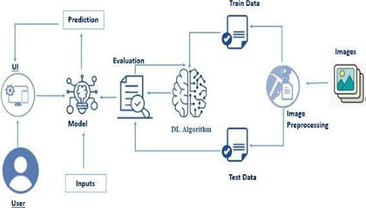

**2. Structure of the Project**

**Project Directory Layout:**

### 

### **Project Objectives**

By the end of the CardMaster: Intelligent Playing Card Recognition project, you will have developed a comprehensive understanding and hands-on experience in the following areas:

1. **Broad Understanding of Data and Its Characteristics**

* You will develop the ability to assess and work with real-world datasets by:
* Exploring the structure and distribution of data, including how class imbalance or image quality can affect learning outcomes.
* Understanding dataset partitioning (train/test/validation splits) and the role each subset plays in model development.
* Learning best practices for organizing and managing large datasets for machine learning workflows.

1. **Data Preprocessing and Transformation Techniques**

* You will become proficient in the crucial steps required to prepare raw data for model training:
* Applying data cleaning techniques to remove noise, handle missing values, and normalize or standardize inputs.
* Identifying and managing outliers using statistical or visual techniques to ensure robust model training.
* Employing image augmentation methods such as rotation, flipping, zooming, and brightness adjustments to increase dataset diversity and model generalization.

1. **Data Visualization and Exploratory Data Analysis (EDA)**

* You will learn how to effectively explore and communicate insights from data through visualization:
* Using libraries like Matplotlib, Seaborn, or Plotly to create meaningful visualizations of image data and model performance (e.g., loss curves, accuracy graphs).
* Plotting confusion matrices, class distributions, and feature maps to better understand model predictions and decision-making processes.
* Gaining experience in interpreting visual results to make informed decisions about model tuning and improvements.

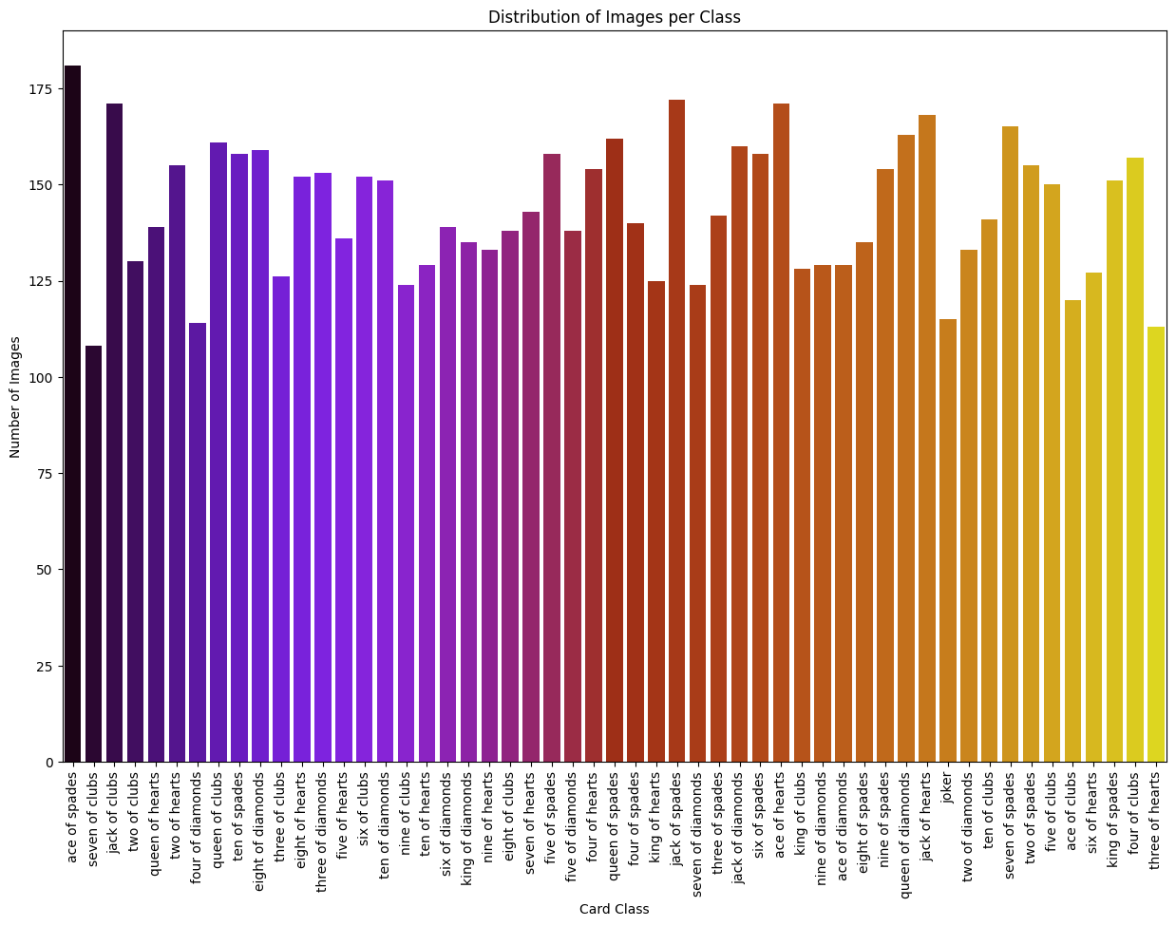

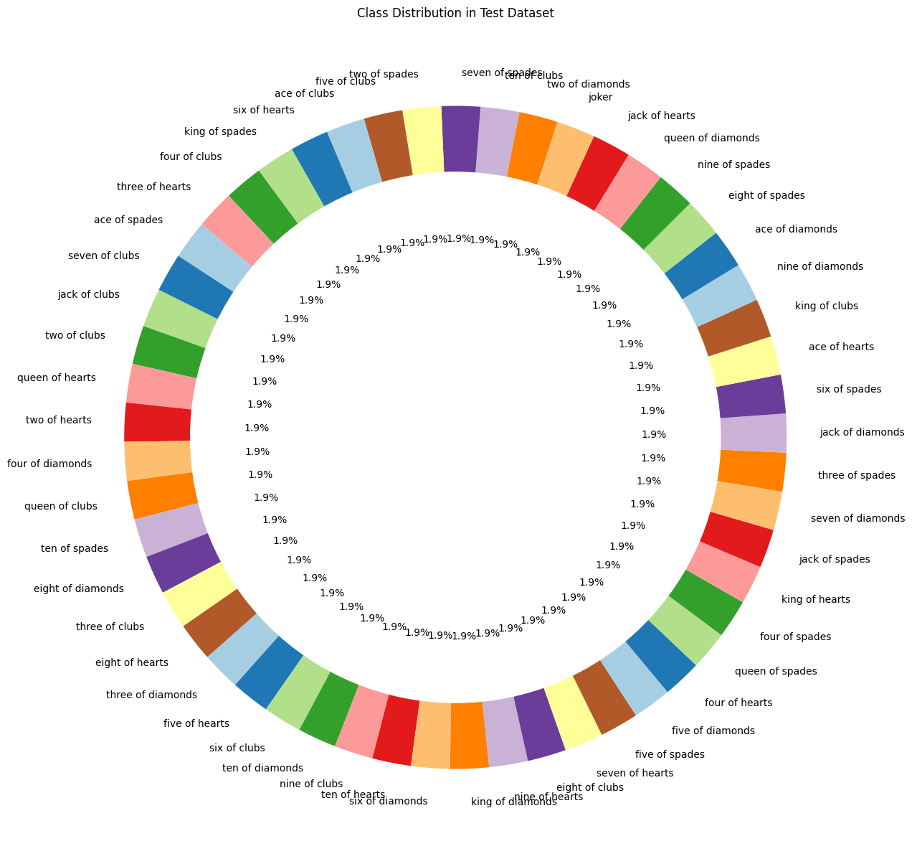

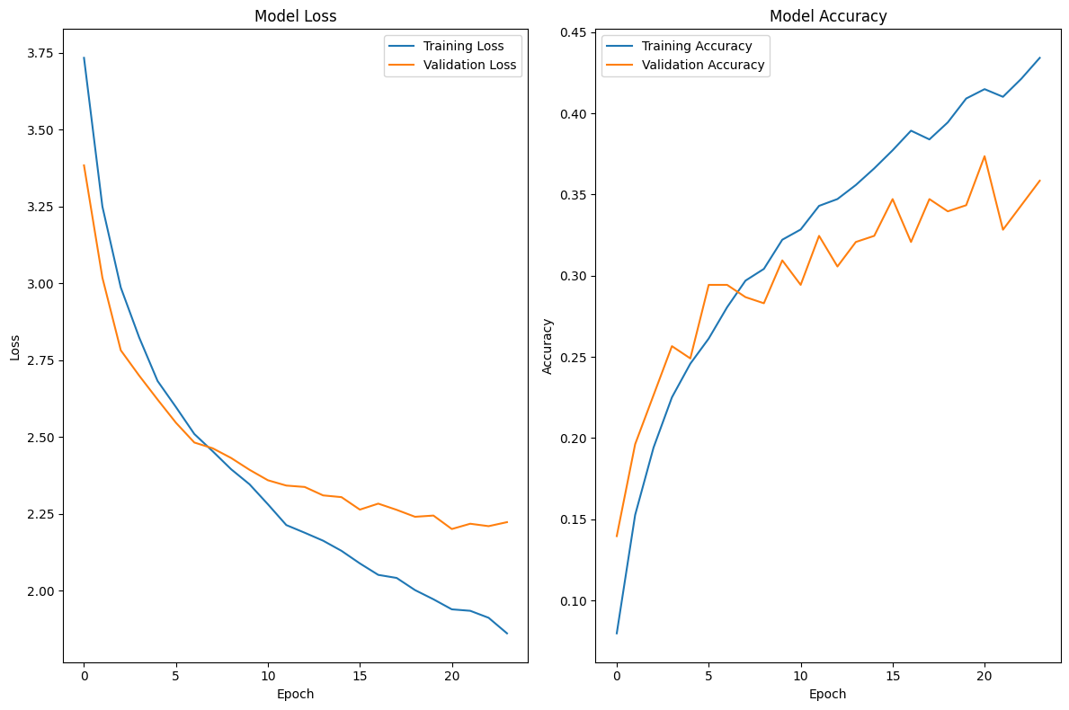

1. **Deep Learning Fundamentals and Techniques**

* You will gain a solid grasp of the core principles and methodologies that underpin modern deep learning. This includes:
* Understanding the architecture and operation of neural networks, especially Convolutional Neural Networks (CNNs).
* Learning how to build, train, and evaluate deep learning models using frameworks such as TensorFlow or PyTorch.
* Gaining insight into the concept of transfer learning, how pre-trained models function, and why they are effective for tasks like image classification.
* Understanding key metrics such as accuracy, loss functions, precision, recall, and how they are used to evaluate model performance.

**Prerequisites**

**Conceptual Requirements:**

Before starting the project, you should have a basic understanding of the following concepts:

* Python programming fundamentals
* Machine Learning and Deep Learning basics
* Image classification and CNN architectures
* Data preprocessing and visualization techniques
* Basic knowledge of Flask for web-based deployment (optional but recommended)

**Python Library Requirements**

To run this project, ensure the following Python libraries are installed:

* numpy==1.24.4 – for numerical operations and array manipulation
* pandas – for data manipulation and analysis
* matplotlib – for data visualization
* seaborn – for advanced visualizations and statistical plotting
* scikit-learn==1.6.1 – for machine learning models and utilities
* scipy – for scientific computing and numerical methods
* ipykernel – for running Jupyter notebooks inside environments
* imbalanced-learn – for handling imbalanced datasets (e.g., using SMOTE)
* joblib==1.3.2 – for saving and loading trained models
* tensorflow – for building and training deep learning models
* Flask – for developing the web-based interface of the application

**Prior Knowledge**

To effectively understand, develop, and deploy the CardMaster: Intelligent Playing Card Recognition project, the following foundational knowledge areas are essential:

**1. Deep Learning Concepts**

A strong grasp of deep learning fundamentals is crucial for building and optimizing image recognition models. Key topics include:

**Neural Networks**

Understanding the structure and functioning of neural networks, including Multilayer Perceptrons (MLP), Convolutional Neural Networks (CNNs), and Recurrent Neural Networks (RNNs).

Read More - [https://www.analyticsvidhya.com/blog/2020/02/cnn- vs-rnn-vs- mlp-analyzing-3-types-of-neural-networks-in-deep-learning/](https://www.analyticsvidhya.com/blog/2020/02/cnn-vs-rnn-vs-mlp-analyzing-3-types-of-neural-networks-in-deep-learning/ )

**Deep Learning Frameworks**

Familiarity with popular frameworks such as TensorFlow and PyTorch, their ecosystems, and when to use each.

Read More - [https://www.knowledgehut.com/blog/data- science/pytorch-vs-tensorflow](https://skillwallet.smartinternz.com/Student/guided_project_info/about:blank)

**Transfer Learning**

Understanding how to use pre-trained models to accelerate training and improve performance on limited data.

Read More - [https://towardsdatascience.com/a-demonstration- of- transfer-learning-of-vgg-convolutional-neural-network-pre- trained- model-with-c9f5b8b1ab0a](https://towardsdatascience.com/a-demonstration-of-transfer-learning-of-vgg-convolutional-neural-network-pre-trained-model-with-c9f5b8b1ab0a )

**VGG16 Architecture**

Knowledge of the VGG16 model, a widely used pre-trained CNN architecture.

Read More - https://www.geeksforgeeks.org/vgg-16-cnn-model/

**Convolutional Neural Networks (CNNs**)

Detailed understanding of how CNNs process images using convolutional layers, pooling, and activation functions

Read More - [https://www.analyticsvidhya.com/blog/2021/05/convolutional- neural-networks-cnn/ s://www.javatpoint.com/k-nearest- neighbor-algorithm-for-machine-learning](https://www.analyticsvidhya.com/blog/2021/05/convolutional-neural-networks-cnn/ s://www.javatpoint.com/k-nearest-neighbor-algorithm-for-machine-learning)

**Overfitting and Regularization**

Techniques such as dropout, L1/L2 regularization, and early stopping to prevent overfitting.

Read More - [https://www.analyticsvidhya.com/blog/2021/07/prevent- overfitting-using-regularization-techniques/](https://www.analyticsvidhya.com/blog/2021/07/prevent-overfitting-using-regularization-techniques/ )

**Optimizers**

Proficiency in choosing and tuning optimizers such as SGD, Adam, and RMSprop for efficient training.

Read More - [https://www.analyticsvidhya.com/blog/2021/10/a- comprehensive-guide-on-deep-learning-optimizers/](https://www.analyticsvidhya.com/blog/2021/10/a-comprehensive-guide-on-deep-learning-optimizers/ ttps://www.analyticsvidhya.com/blog/2019/08/11-important-model-evaluation-error-metrics/)

**2. Flask Framework (Web Application Basics)**

A basic understanding of the Flask framework is required for deploying the trained model via a web interface. This includes:

* Creating routes and handling HTTP requests
* Setting up endpoints to receive user input and send predictions.
* Rendering HTML templates using Jinja2
* Dynamically displaying results and form elements in the frontend.
* Managing form input and backend communication
* Capturing user inputs and passing them to the model for prediction.
* Serving predictions through an interactive web interface
* Displaying model output in real time using Flask.

Watch tutorial: [https://www.wetube.com/watch?v=lj4I_CvBnt0](https://www.youtube.com/watch?v=lj4I_CvBnt0)

**Created by:**

* Pravarsh Prateek: [pravarsh.23bce11025@vitbhopal.ac.in](mailto:pravarsh.23bce11025@vitbhopal.ac.in)
* Parth Abhay Deshpande:[patrh.23bce11087@vitbhopal.ac.in](mailto:patrh.23bce11087@vitbhopal.ac.in)
* Parth Sanjay Deore: [parth.23bce11049@gmail.com](mailto:parth.23bce11049@gmail.com)